Right Trapezoid

Definition
# Source: AI Source: Provided by: [Data Path: Persons Table -> ID Column: 1, Name_En Column: Motasem Essam] -> From: [ChatGPT] on [7/25/2026]
A right trapezoid is a trapezoid that has two right angles.
For trapezoid $ABCD$, if
$$AB∥CD$$
and
$$∠A=∠D={90}^{∘},$$
then $ABCD$is a right trapezoid.
The side connecting the two right angles is perpendicular to the parallel bases and therefore represents the height of the trapezoid.
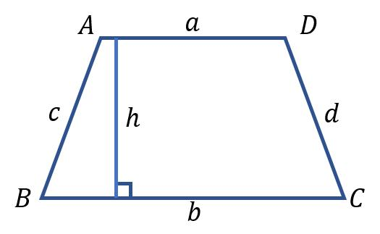
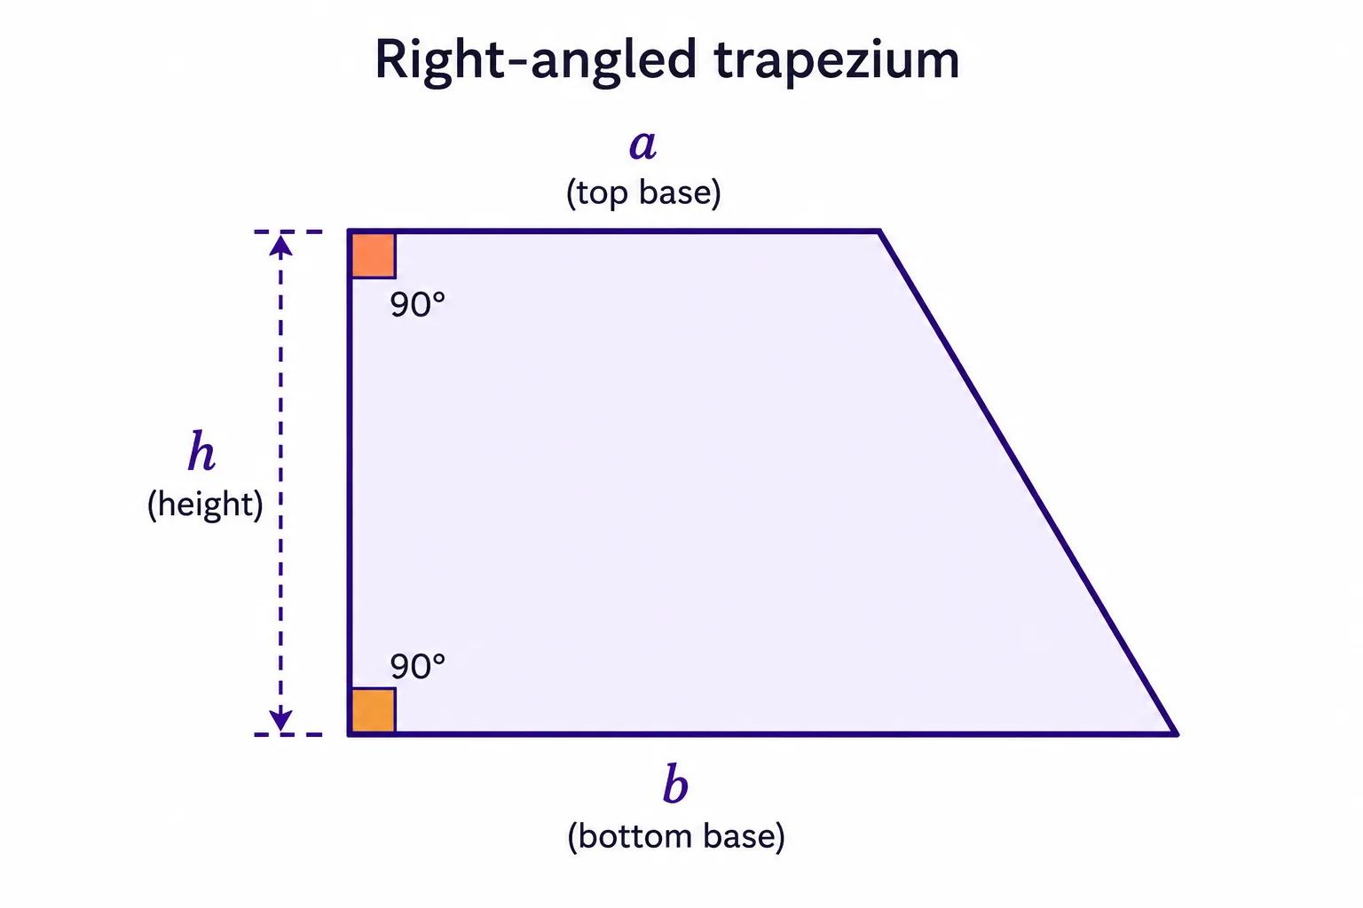
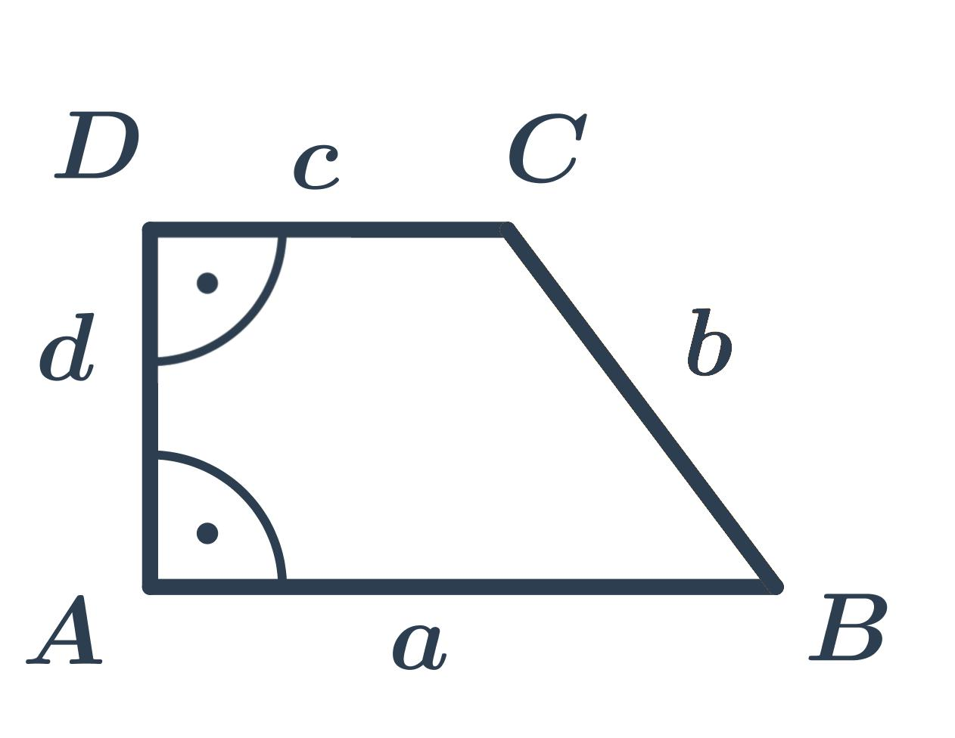
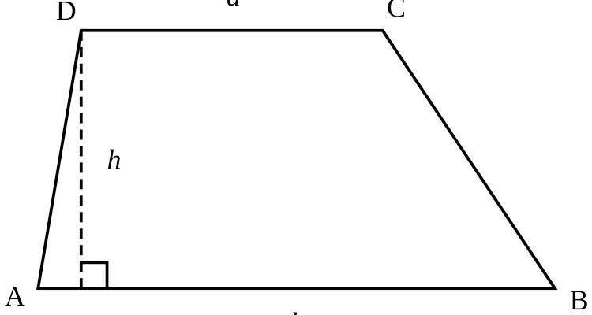
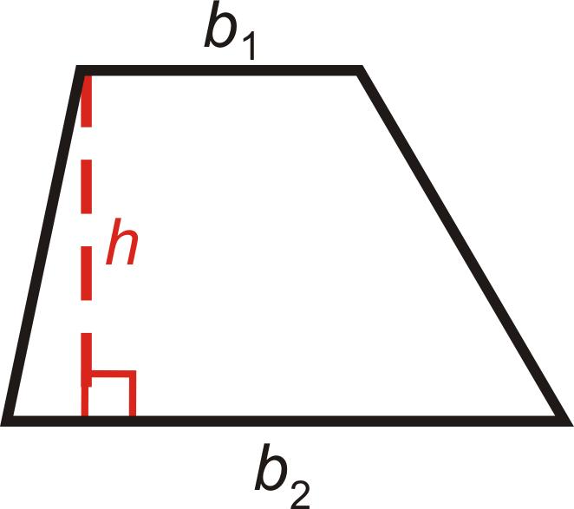

Purpose
# Source: AI Source: Provided by: [Data Path: Persons Table -> ID Column: 1, Name_En Column: Motasem Essam] -> From: [ChatGPT] on [7/25/2026]
A right trapezoid is useful for:
- Studying trapezoids containing right angles.
- Calculating area and perimeter.
- Applying the Pythagorean theorem.
- Finding unknown lengths using right triangles.
- Modeling structures and objects with one perpendicular side.
- Connecting trapezoid geometry with right-triangle geometry.

Fundamental Elements
# Source: AI Source: Provided by: [Data Path: Persons Table -> ID Column: 1, Name_En Column: Motasem Essam] -> From: [ChatGPT] on [7/25/2026]
Consider right trapezoid $ABCD$, where
$$AB∥CD$$
and
$$∠A=∠D={90}^{∘}.$$

1. Bases
# Source: AI Source: Provided by: [Data Path: Persons Table -> ID Column: 1, Name_En Column: Motasem Essam] -> From: [ChatGPT] on [7/25/2026]
The parallel sides are
$$\overset{‾}{AB}$$
and
$$\overset{‾}{CD}.$$

2. Legs
# Source: AI Source: Provided by: [Data Path: Persons Table -> ID Column: 1, Name_En Column: Motasem Essam] -> From: [ChatGPT] on [7/25/2026]
The non-parallel sides are
$$\overset{‾}{AD}$$
and
$$\overset{‾}{BC}.$$
However, unlike an isosceles trapezoid, the legs do not have to be congruent.

3. Right Leg
# Source: AI Source: Provided by: [Data Path: Persons Table -> ID Column: 1, Name_En Column: Motasem Essam] -> From: [ChatGPT] on [7/25/2026]
The side $AD$is perpendicular to both bases:
$$AD⊥AB$$
and
$$AD⊥CD.$$
Therefore,
$$\boxed{AD=h}$$
where $h$is the height.

4. Diagonals
# Source: AI Source: Provided by: [Data Path: Persons Table -> ID Column: 1, Name_En Column: Motasem Essam] -> From: [ChatGPT] on [7/25/2026]
The diagonals are
$$\overset{‾}{AC}$$
and
$$\overset{‾}{BD}.$$
They are not generally congruent or perpendicular.
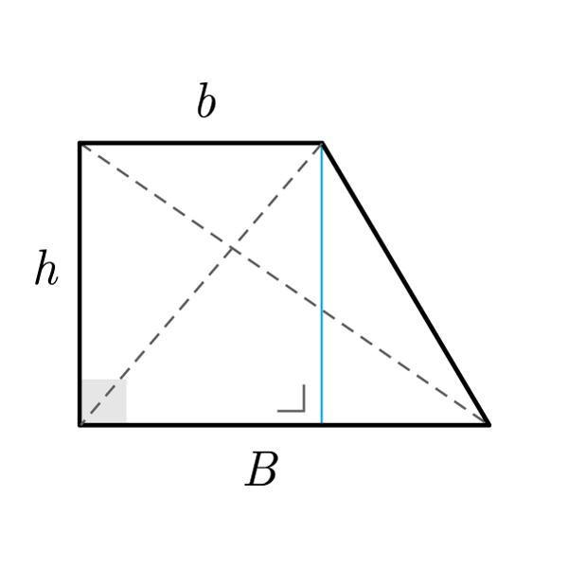
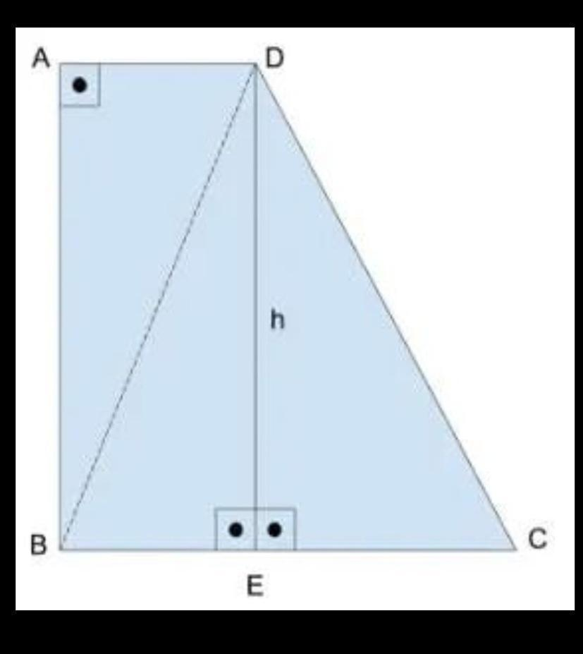

Main Properties
# Source: AI Source: Provided by: [Data Path: Persons Table -> ID Column: 1, Name_En Column: Motasem Essam] -> From: [ChatGPT] on [7/25/2026]
1. Two Right Angles
The defining property is that two angles are right angles:
$$\boxed{∠A=∠D={90}^{∘}}$$
Because the interior angles of a quadrilateral sum to ${360}^{∘}$, the remaining two angles satisfy
$$∠B+∠C={180}^{∘}.$$

2. One Leg Is the Height
The perpendicular leg is exactly the height.
If $AD$is perpendicular to the bases, then
$$\boxed{h=AD}.$$
This makes area calculations particularly convenient.

3. Parallel Bases
The defining parallel relationship is
$$\boxed{AB∥CD}.$$

4. Consecutive Non-Right Angles Are Supplementary
Since $AB∥CD$,
$$\boxed{∠B+∠C={180}^{∘}}.$$
For example, if
$$∠B={60}^{∘},$$
then
$$∠C={120}^{∘}.$$

5. Legs Are Not Generally Equal
A right trapezoid does not generally satisfy
$$AD=BC.$$
For example,
$$AD=5\text{ cm}$$
and
$$BC=7\text{ cm}$$
can occur in a right trapezoid.

Mathematical Representation
# Source: AI Source: Provided by: [Data Path: Persons Table -> ID Column: 1, Name_En Column: Motasem Essam] -> From: [ChatGPT] on [7/25/2026]
Let:
- $a$= length of one base
- $b$= length of the other base
- $h$= height
- $l$= slanted leg
Then
$$AB=a, CD=b, AD=h.$$

Area
# Source: AI Source: Provided by: [Data Path: Persons Table -> ID Column: 1, Name_En Column: Motasem Essam] -> From: [ChatGPT] on [7/25/2026]
The area is
$$\boxed{A=\frac{\left(a+b\right)h}{2}}$$
Because $AD=h$, the perpendicular leg can be directly substituted for the height.

Perimeter
# Source: AI Source: Provided by: [Data Path: Persons Table -> ID Column: 1, Name_En Column: Motasem Essam] -> From: [ChatGPT] on [7/25/2026]
The perimeter is
$$P=a+b+h+l.$$
Therefore,
$$\boxed{P=a+b+h+l}$$

Pythagorean Theorem Relationship
# Source: AI Source: Provided by: [Data Path: Persons Table -> ID Column: 1, Name_En Column: Motasem Essam] -> From: [ChatGPT] on [7/25/2026]
A right trapezoid can be divided into a rectangle and a right triangle.
If the longer base exceeds the shorter base by
$$b-a,$$
then the horizontal leg of the resulting right triangle is
$$b-a.$$
Therefore, if the slanted leg is $l$,
$$l^{2}=h^{2}+{\left(b-a\right)}^{2}.$$
Thus,
$$\boxed{l=\sqrt{h^{2}+{\left(b-a\right)}^{2}}}$$
and, if $l$and $h$are known,
$$\boxed{h=\sqrt{l^{2}-{\left(b-a\right)}^{2}}}.$$
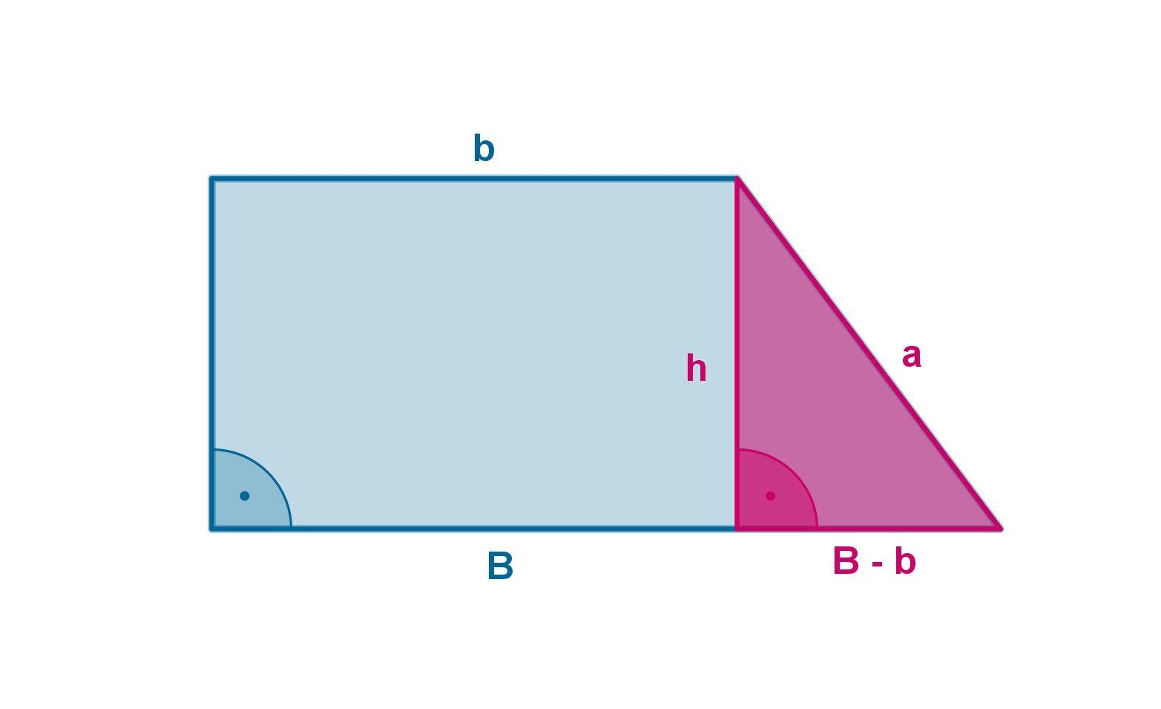
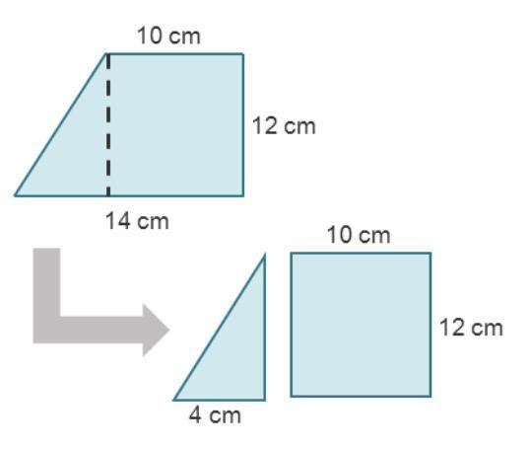
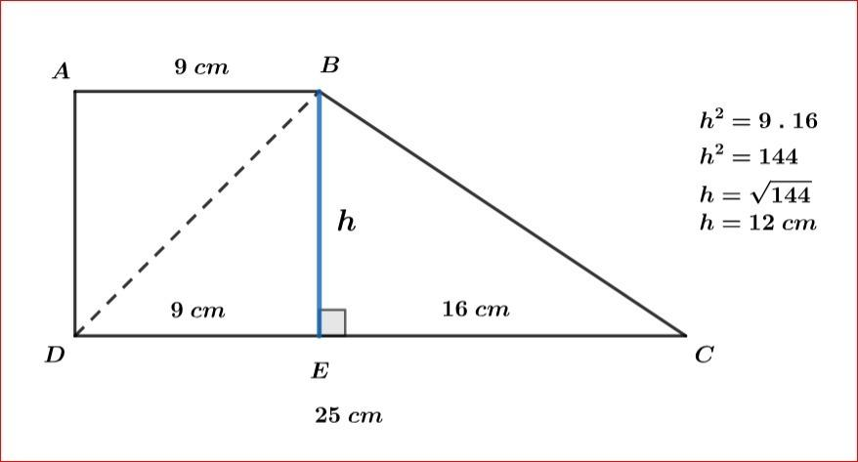
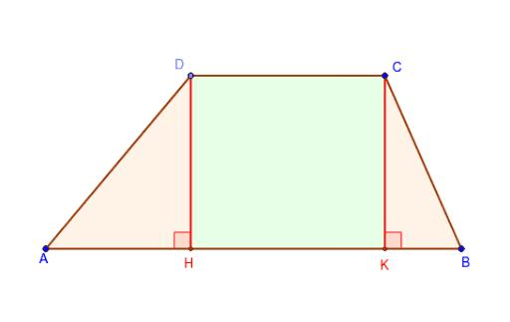
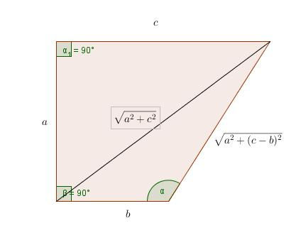

Example 1 — Area
# Source: AI Source: Provided by: [Data Path: Persons Table -> ID Column: 1, Name_En Column: Motasem Essam] -> From: [ChatGPT] on [7/25/2026]
A right trapezoid has bases
$$a=8\text{ cm}$$
and
$$b=14\text{ cm},$$
with height
$$h=5\text{ cm}.$$
Using
$$A=\frac{\left(a+b\right)h}{2},$$
we get
$$A=\frac{\left(8+14\right)\left(5\right)}{2} \\ A=\frac{22×5}{2} \\ \boxed{A=55{\text{ cm}}^{2}}$$

Example 2 — Perimeter
# Source: AI Source: Provided by: [Data Path: Persons Table -> ID Column: 1, Name_En Column: Motasem Essam] -> From: [ChatGPT] on [7/25/2026]
Suppose a right trapezoid has:
$$a=8\text{ cm} \\ b=14\text{ cm} \\ h=5\text{ cm}$$
and slanted leg
$$l=7.81\text{ cm}.$$
Then
$$P=a+b+h+l \\ P=8+14+5+7.81 \\ \boxed{P=34.81\text{ cm}}$$

Example 3 — Finding the Slanted Leg
# Source: AI Source: Provided by: [Data Path: Persons Table -> ID Column: 1, Name_En Column: Motasem Essam] -> From: [ChatGPT] on [7/25/2026]
Suppose
$$a=8\text{ cm}, \\ b=14\text{ cm},$$
and
$$h=5\text{ cm}.$$
The horizontal difference between the bases is
$$b-a=14-8=6\text{ cm}.$$
Using the Pythagorean theorem:
$$l^{2}=h^{2}+{\left(b-a\right)}^{2} \\ l^{2}=5^{2}+6^{2} \\ l^{2}=25+36 \\ l^{2}=61$$
Therefore,
$$\boxed{l=\sqrt{61}\text{ cm}}$$
or approximately
$$\boxed{l≈7.81\text{ cm}}.$$

Example 4 — Finding an Unknown Angle
# Source: AI Source: Provided by: [Data Path: Persons Table -> ID Column: 1, Name_En Column: Motasem Essam] -> From: [ChatGPT] on [7/25/2026]
Suppose
$$∠B={70}^{∘}.$$
Because $AB∥CD$,
$$∠B+∠C={180}^{∘}.$$
Therefore,
$${70}^{∘}+∠C={180}^{∘} \\ \boxed{∠C={110}^{∘}}.$$
The four angles are therefore
$${90}^{∘}, {70}^{∘}, {110}^{∘}, {90}^{∘}.$$

Midsegment
# Source: AI Source: Provided by: [Data Path: Persons Table -> ID Column: 1, Name_En Column: Motasem Essam] -> From: [ChatGPT] on [7/25/2026]
Like every trapezoid, a right trapezoid has a midsegment connecting the midpoints of its legs.
The midsegment is parallel to the bases.
If the bases have lengths $a$and $b$,
$$\boxed{m=\frac{a+b}{2}}.$$
The area can therefore also be expressed as
$$\boxed{A=mh}.$$
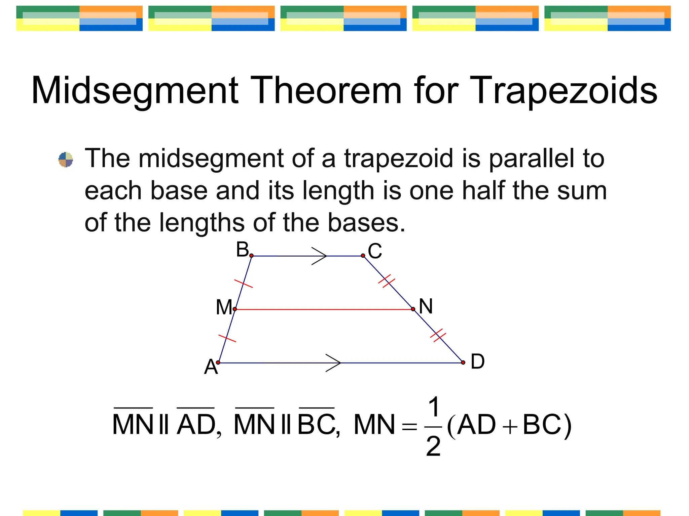
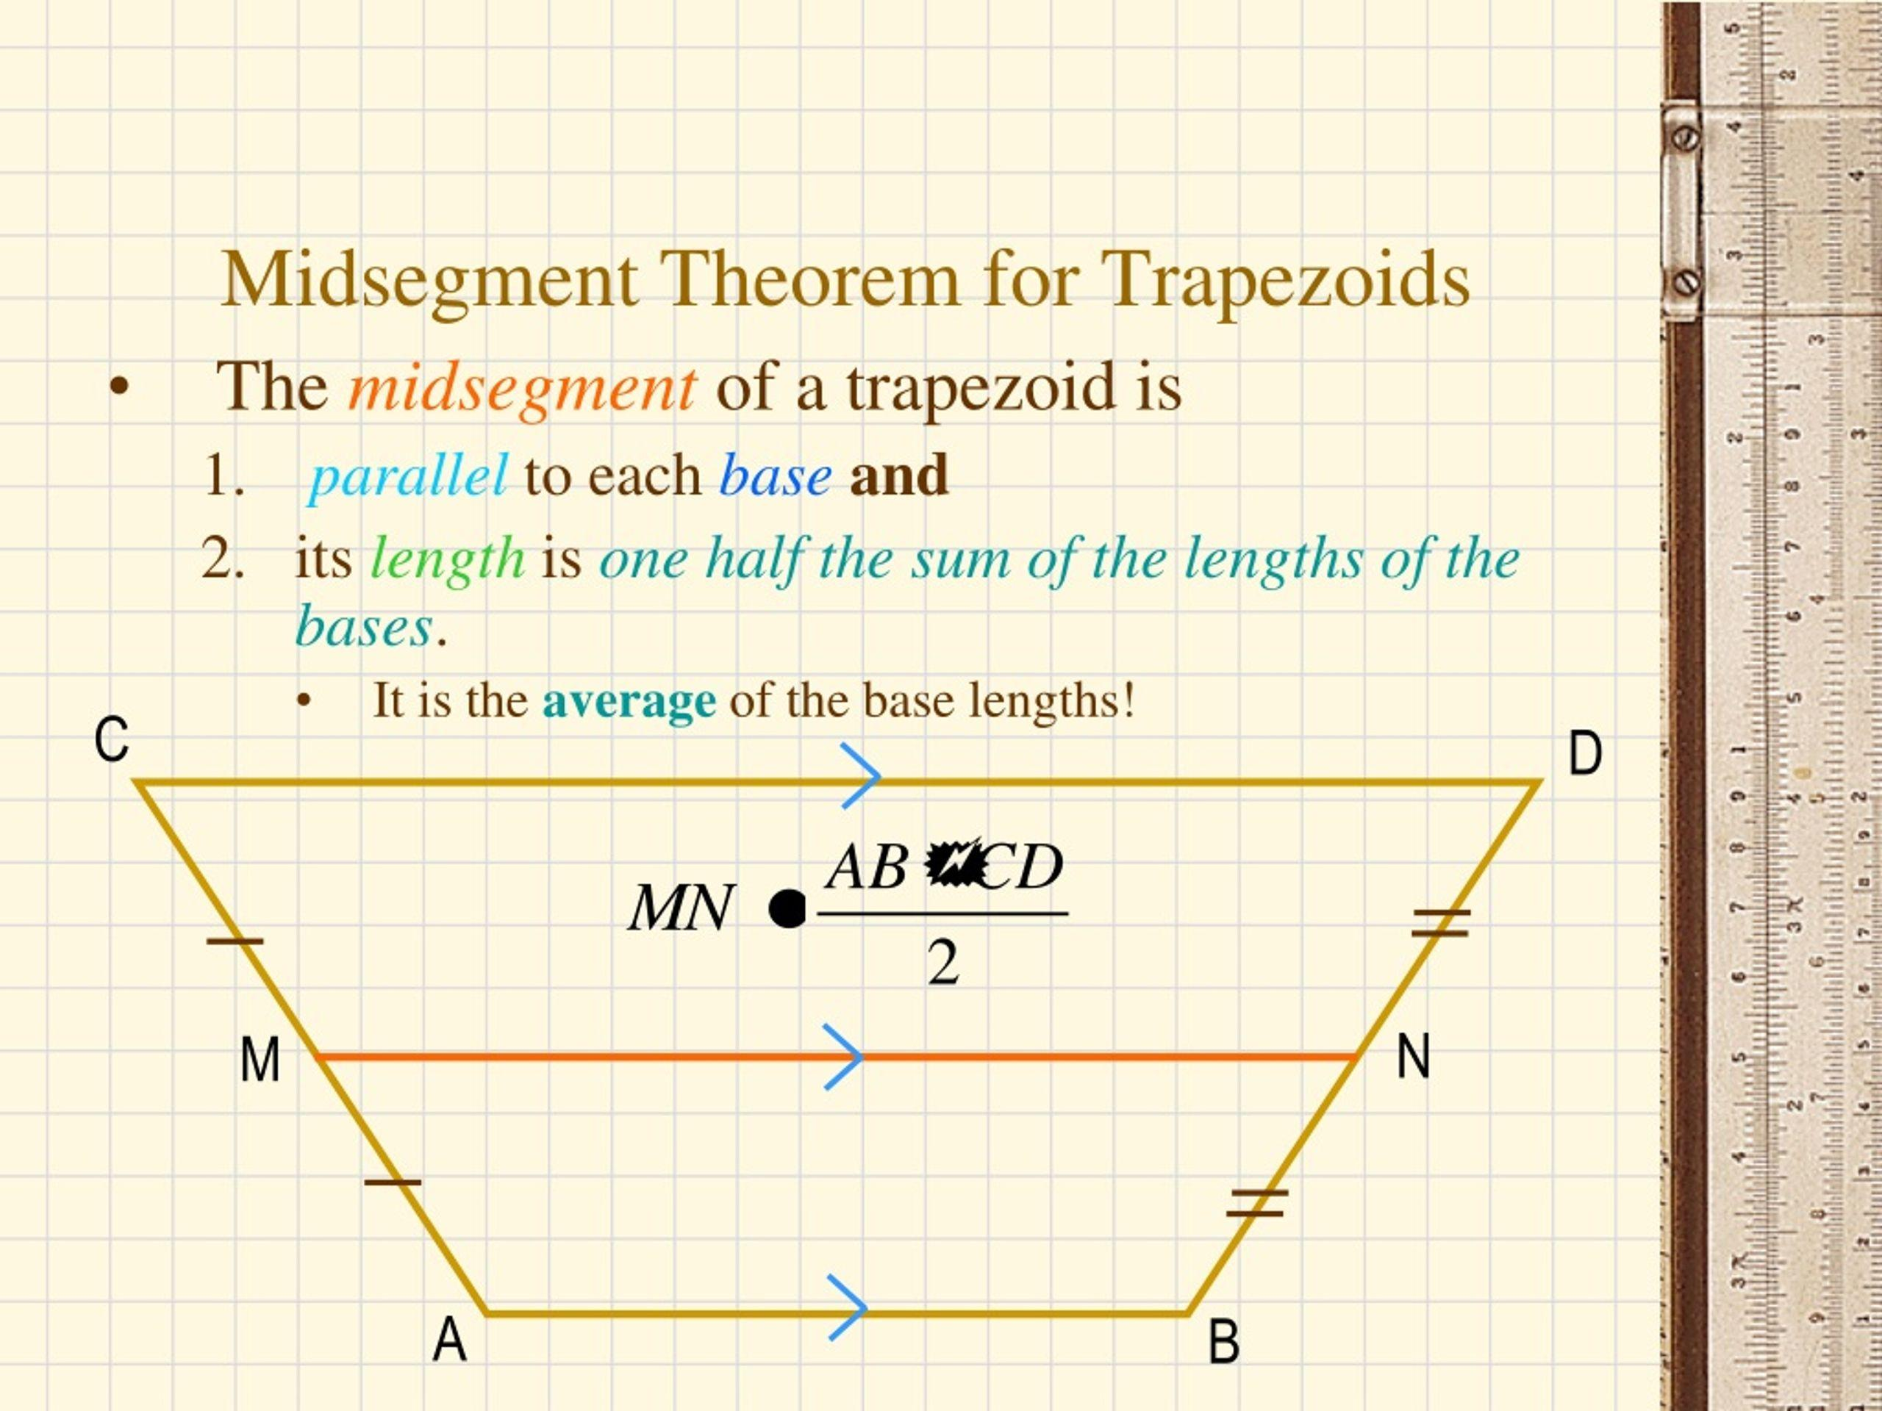
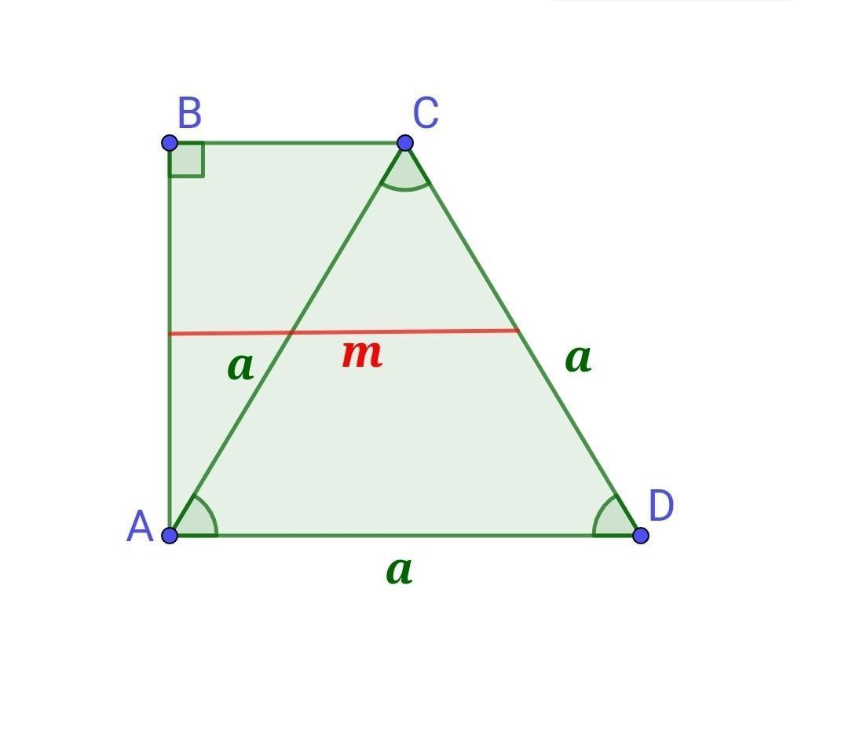
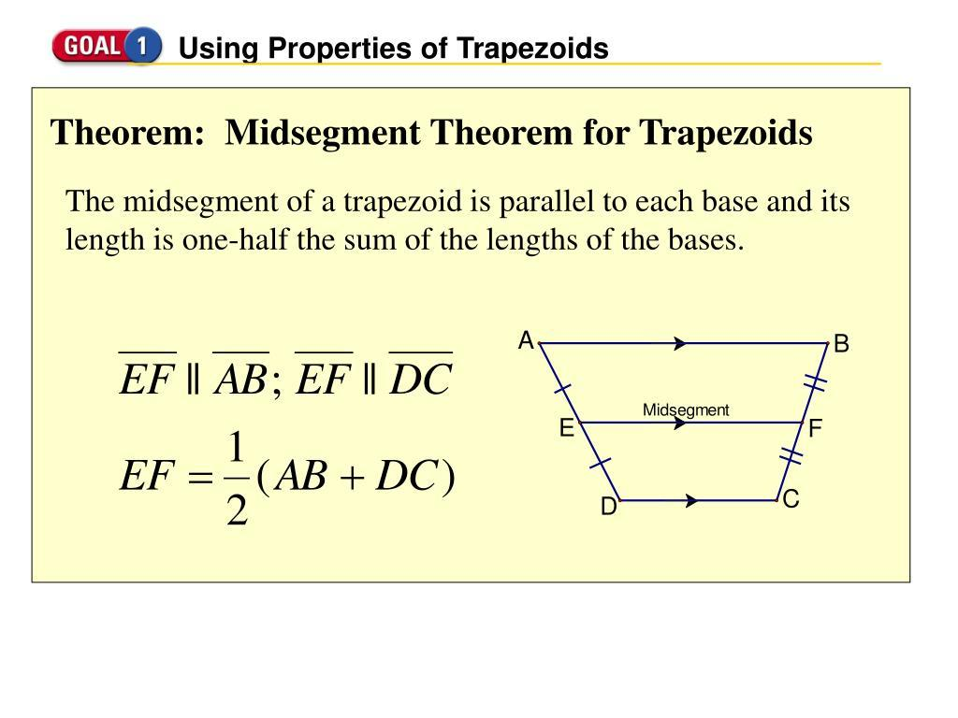

Relationship with Other Trapezoids
# Source: AI Source: Provided by: [Data Path: Persons Table -> ID Column: 1, Name_En Column: Motasem Essam] -> From: [ChatGPT] on [7/25/2026]
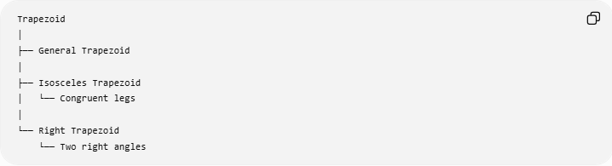
Trapezoid
│
├── General Trapezoid
│
├── Isosceles Trapezoid
│ └── Congruent legs
│
└── Right Trapezoid
└── Two right angles
The key distinction is:
$$\boxed{\text{Isosceles Trapezoid }\text{→} \text{Congruent} \text{Legs}}$$
while
$$\boxed{\text{Right Trapezoid }\text{→} \text{Two} \text{Right} \text{Angles}}$$

Comparison with General and Isosceles Trapezoids
# Source: AI Source: Provided by: [Data Path: Persons Table -> ID Column: 1, Name_En Column: Motasem Essam] -> From: [ChatGPT] on [7/25/2026]
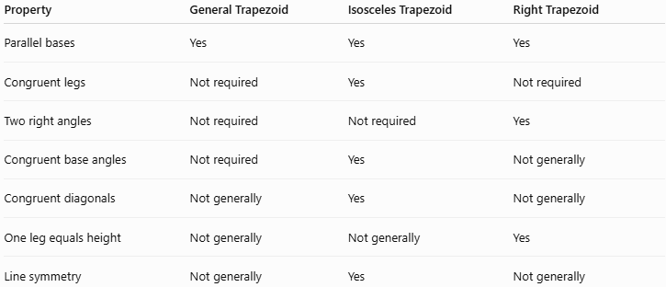
Property | General Trapezoid | Isosceles Trapezoid | Right Trapezoid
Parallel bases | Yes | Yes | Yes
Congruent legs | Not required | Yes | Not required
Two right angles | Not required | Not required | Yes
Congruent base angles | Not required | Yes | Not generally
Congruent diagonals | Not generally | Yes | Not generally
One leg equals height | Not generally | Not generally | Yes
Line symmetry | Not generally | Yes | Not generally

Comparison with Rectangle
# Source: AI Source: Provided by: [Data Path: Persons Table -> ID Column: 1, Name_En Column: Motasem Essam] -> From: [ChatGPT] on [7/25/2026]
A right trapezoid is closely related to a rectangle.
A rectangle has:
$$4\text{ right angles}$$
while a typical right trapezoid has:
$$2\text{ right angles}.$$
Therefore, a rectangle can be viewed as a special limiting case of a right-trapezoid-like structure under some inclusive definitions, but under the common classification of trapezoids as having exactly one pair of parallel sides, a rectangle is classified separately.

Real-World Applications
# Source: AI Source: Provided by: [Data Path: Persons Table -> ID Column: 1, Name_En Column: Motasem Essam] -> From: [ChatGPT] on [7/25/2026]
Right trapezoids can be used to represent:
- Ramps
- Stair profiles
- Architectural structures
- Roof sections
- Support brackets
- Engineering components
- Machine parts
- Sloped walls
- Construction profiles
- Land and property boundaries

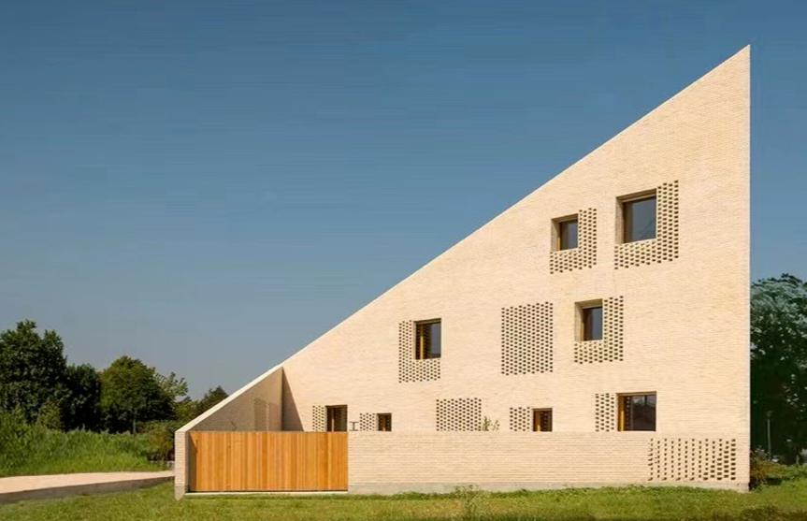
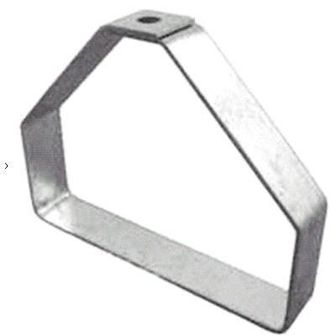
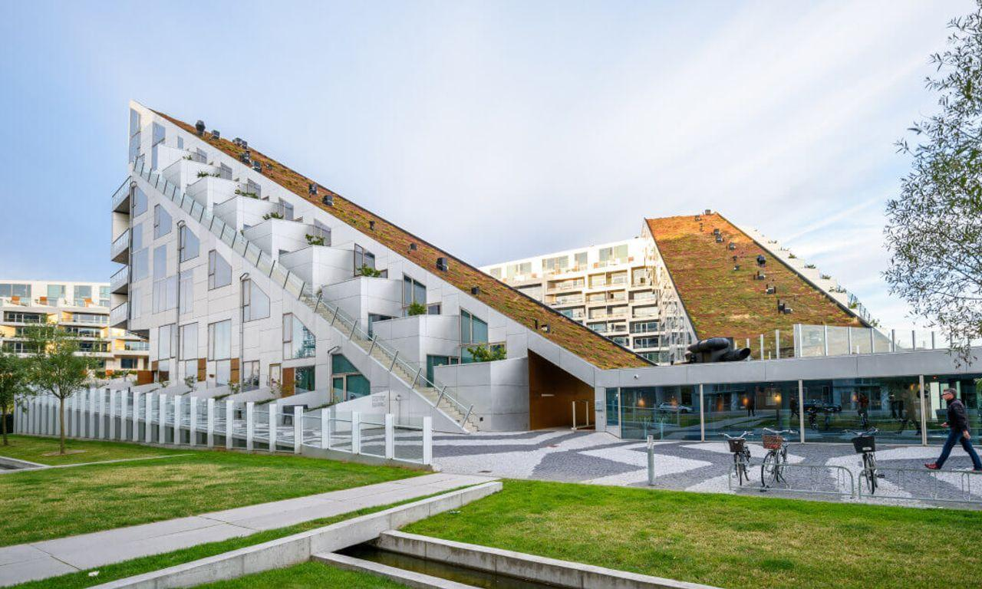

Advantages
# Source: AI Source: Provided by: [Data Path: Persons Table -> ID Column: 1, Name_En Column: Motasem Essam] -> From: [ChatGPT] on [7/25/2026]
- One leg directly gives the height.
- Area calculations are straightforward.
- Can be decomposed into a rectangle and a right triangle.
- Pythagorean theorem can be applied easily.
- Useful for modeling structures with perpendicular and sloped sides.

Limitations
# Source: AI Source: Provided by: [Data Path: Persons Table -> ID Column: 1, Name_En Column: Motasem Essam] -> From: [ChatGPT] on [7/25/2026]
A general right trapezoid does not necessarily have:
- Congruent legs.
- Congruent diagonals.
- Perpendicular diagonals.
- Line symmetry.
- Four right angles.
These properties belong to other special quadrilaterals or special trapezoids.

Key Points
# Source: AI Source: Provided by: [Data Path: Persons Table -> ID Column: 1, Name_En Column: Motasem Essam] -> From: [ChatGPT] on [7/25/2026]
- A right trapezoid is a trapezoid with two right angles.
- Its bases are parallel:
$$\boxed{AB∥CD}$$
- The two right angles are:
$$\boxed{∠A=∠D={90}^{∘}}$$
- The perpendicular leg is the height:
$$\boxed{AD=h}$$
- The remaining two angles are supplementary:
$$\boxed{∠B+∠C={180}^{∘}}$$
- Area:
$$\boxed{A=\frac{\left(a+b\right)h}{2}}$$
- Perimeter:
$$\boxed{P=a+b+h+l}$$
- The slanted leg can be found using:
$$\boxed{l=\sqrt{h^{2}+{\left(b-a\right)}^{2}}}$$
- It does not generally have congruent legs or congruent diagonals.

Conclusion
# Source: AI Source: Provided by: [Data Path: Persons Table -> ID Column: 1, Name_En Column: Motasem Essam] -> From: [ChatGPT] on [7/25/2026]
A Right Trapezoid is a special type of trapezoid characterized by two right angles. Its perpendicular leg is also the height, making area calculations particularly simple. Because a right trapezoid can be decomposed into a rectangle and a right triangle, the Pythagorean theorem is especially useful for finding unknown lengths.

